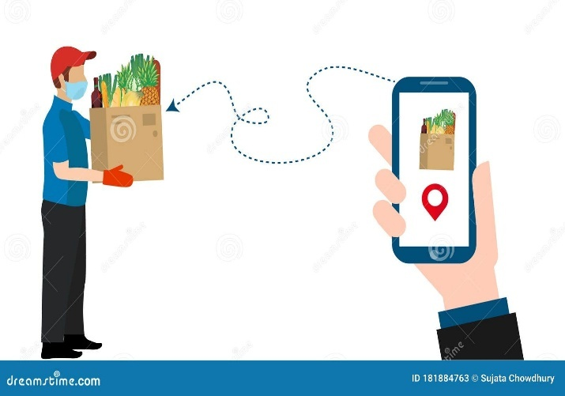 **PROJECT REPORT ON**

**“ FRUITKHA WEBSITE ”**

**Submit by :-**   **Internal Guide Of :-**

Abhay Gajjar Prof. Rahul Sir

**Submitted to**

**Tops Technologies pvt.ltd**

**(**Approved by & Affiliated to the GTU**)**

Baleshwar Apart. ,Prahladnagar, Sarkhej-Gandhinagar

Highway, Ahemedabad,382481.

\*\***ACKNOWLEDGEMENT**\*\*

* Project requires a lot of consideration, desire and hard work.
* Project is like a bridge between theoretical and practical working.
* Encouragement, Inspiration and Motivation has always played a key role in the success of any venture.
* On the very Outset of this Project report, we would like to extent our sincere and heartfelt gratitude to all those who helped us in various capacities in undertaking this project work.
* We would like to also thank and appreciate Prof. Rahul Sir who has also guided along with the sparing her valuable time and efforts for us.
* We have taken efforts in this project. It would not have been possible without the kind support and help of man individuals and organizations.
* Then I would like to thank my friends and classmates who have helped us with their valuable suggestions and guidance has been very helpful in various phases of the completion of the project.

|  |  |  |
| --- | --- | --- |
| Serial No. | Topic | Page No. |
|  | **Project Profile :**  **-Purpose**  **-Tools and Technology** | 4 |
|  | **System-Flow Diagram**  **UML Diagrams**  **-Use Case Diagrams**  **-Data Flow Diagrams**  **- ER Diagram** | 7 |
|  | **Data Dictionary** | 17 |
|  | **Conclusion** | 29 |
|  | **Bibliography** | 30 |

\*\***PROJECT PROFILE**\*\*

**-- Purpose --**

**-- Development Tools & Technology --**

**\*\*Purpose\*\***

The primary purpose of creating the Fruitkha website is to provide an accessible and user-friendly platform for customers to purchase high-quality fruits and vegetables online.

It aims to streamline the shopping experience with an intuitive interface, detailed product listings, and secure payment options, catering to the growing demand for convenient and reliable grocery shopping.

By offering a wide variety of fresh produce, Fruitkha ensures that customers have access to healthy and organic options, delivered right to their doorstep.

The goal is to create a seamless and enjoyable shopping experience while supporting a healthy lifestyle for its customers.



**\*\*Development Tools & Technology\*\***

**Front-End** :- Html 5 , Javascript

Css 3 , bootstrap.

**Back-End** :- JSP, Servlet, JDBC, Mysql.

**Tools** :- Draw.io , Eclipse.



* **System Flow Diagram**

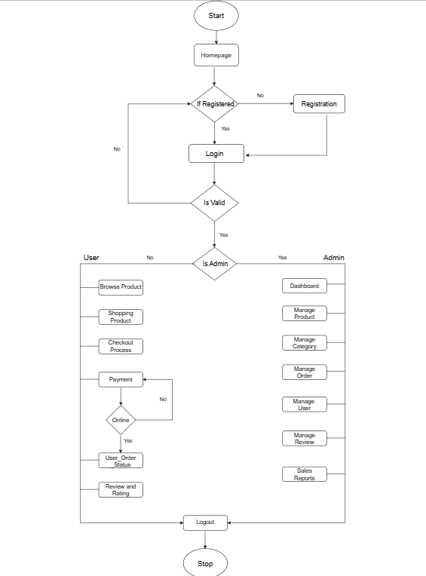

**\*\* UML DIAGRAMS\*\***

* **Use Case Diagram**

1. **User usecase Diagram**
2. **Admin usecase Diagram**

* **Data Flow Diagram**

1. **DFD level 0 Diagram**
2. **DFD level 1 Diagram**
3. **DFD level 2 User Diagram**
4. **DFD Admin Diagram**

* **ER Diagram**
* **User usecase Diagram**

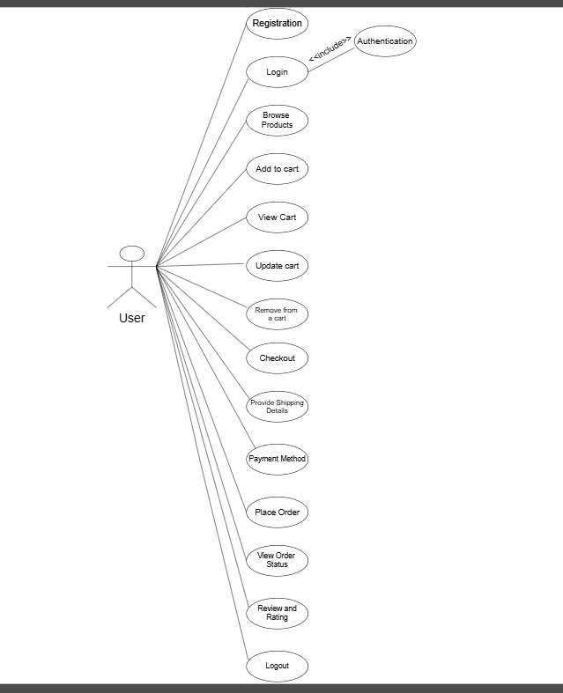

* 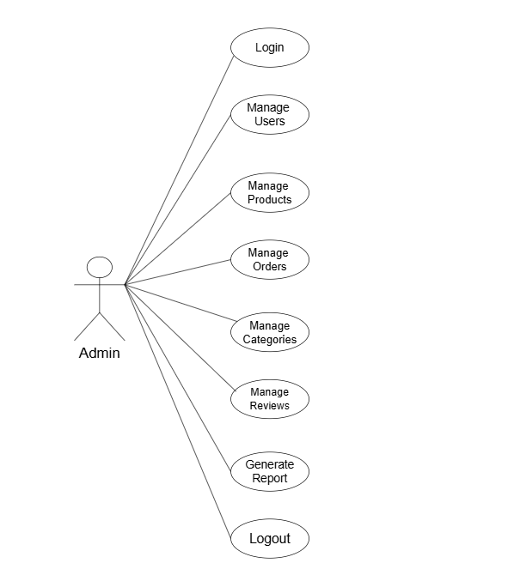**Admin usecase Diagram**

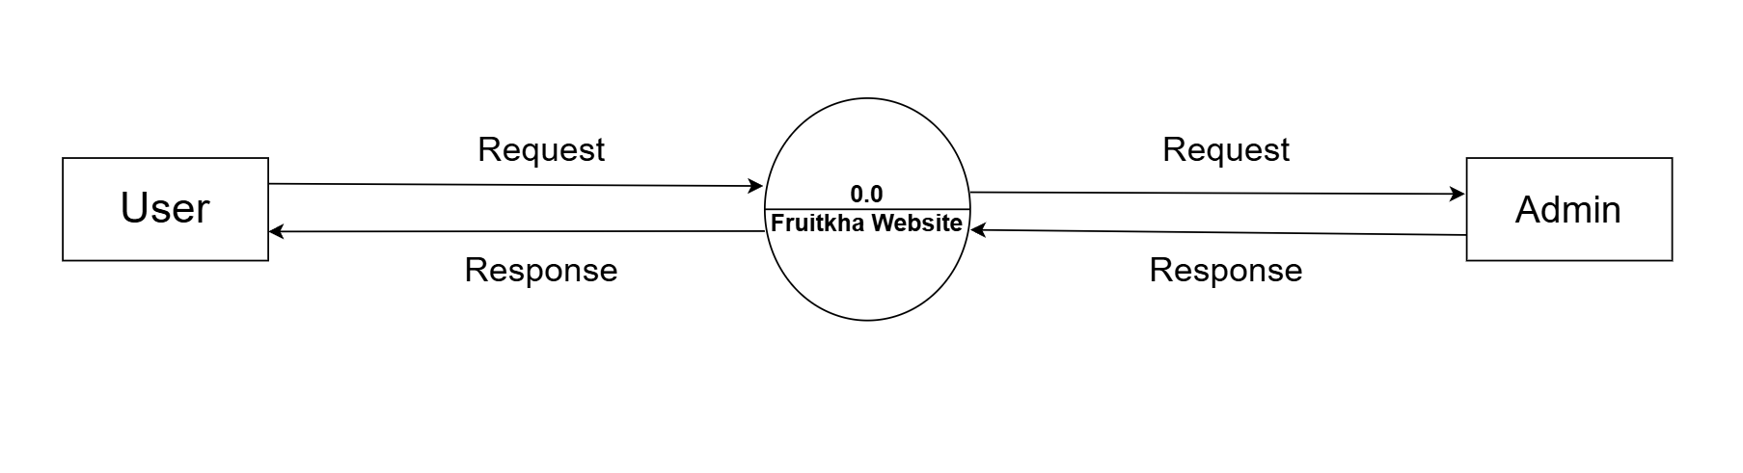 **\* DFD Level 0 Diagram \***

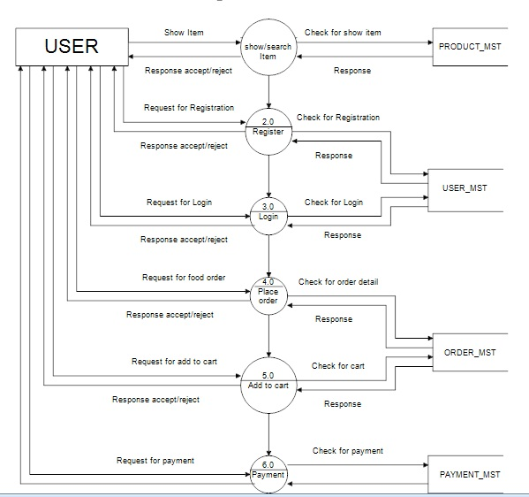 **\* DFD Level 1 Diagram \***

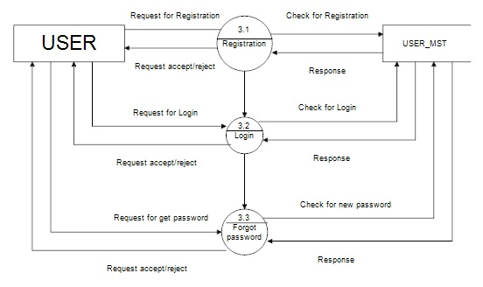 **\* DFD Level 2 User Diagram \***

**\* DFD Admin Diagram \***

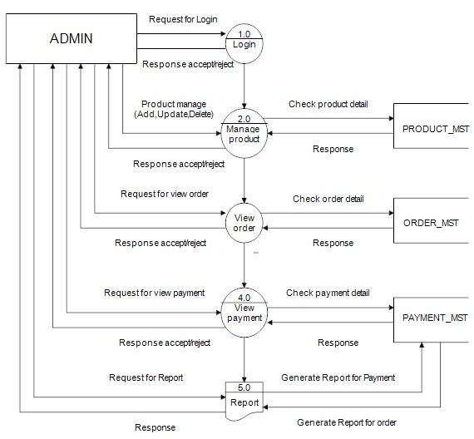

* 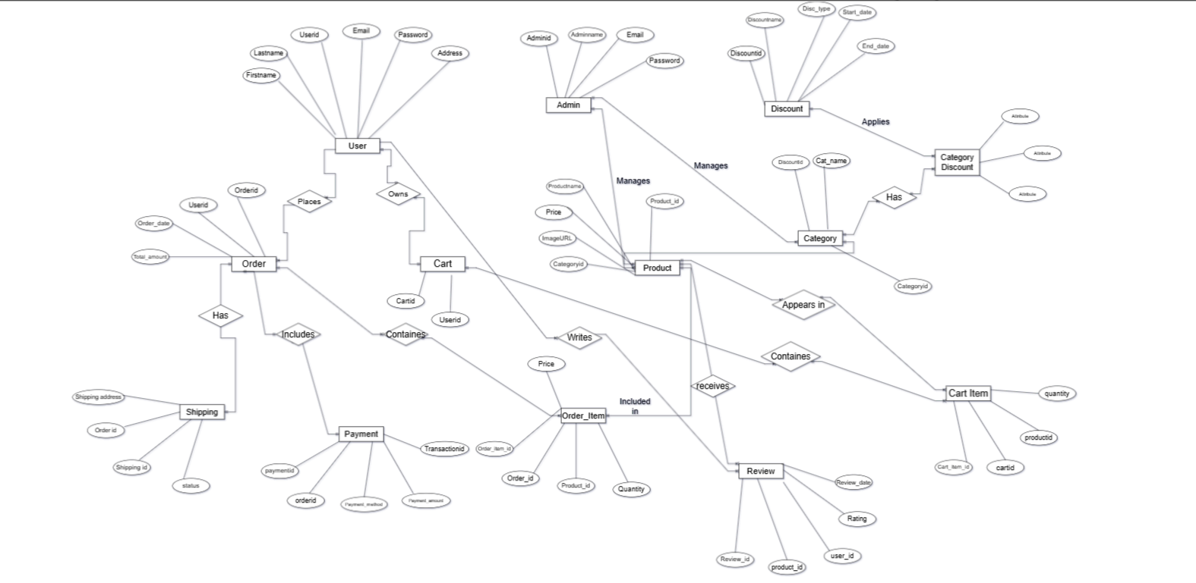**ER-DIAGRAM**

**Data Dictionary**

|  |  |
| --- | --- |
| **TABLE NO.** | **LIST OF TABLE** |
| **1.** | **Customer Table** |
| **2.** | **Product Table** |
| **3.** | **Admin Table** |
| **4.** | **Categories Table** |
| **5.** | **Discount Table** |
| **6.** | **Order Table** |
| **7.** | **Order_Details Table** |
| **8.** | **Cart Table** |
| **9.** | **Cart_Items Table** |
| **10.** | **Payment Table** |
| **11.** | **Review Table** |
| **12.** | **Shipping Table** |

**\*Customer Table\***

|  |  |  |  |  |
| --- | --- | --- | --- | --- |
| Field name | Datatype | Number of size for storage | Constraints | Description |
| User_id | INT | 10 | PRIMARY KEY | Unique identifier for user |
| Firstname | VARCHAR2 | 40 | NOT NULL | User’s First Name |
| Lastname | VARCHAR2 | 40 | NOT NULL | User’s Last Name |
| Email | VARCHAR2 | 20 | NOT NULL | User’s Email Address |
| Password | VARCHAR2 | 15 | NOT NULL | Hashed Password for Security |
| Phoneno | VARCHAR | 20- | NOT NULL | User’s Contact Number |
| Address | TEXT |  |  | User’s Address |
| Registrationdate | DATETIME |  |  | Date and Time of user Registration |

**\*Product Table\***

|  |  |  |  |  |
| --- | --- | --- | --- | --- |
| Field name | Datatype | Number of size for storage | Constraints | Description |
| Product_id | INT | 10 | PRIMARY KEY | Unique identifier for each product |
| Product_name | VARCHAR2 | 30 | NOT NULL | Name of the Product. |
| Category_id | INT | 10 | NOT NULL | Foreign key to categories table |
| Description | TEXT |  | NOT NULL | Detailed Description of the product. |
| Price | DECIMAL(10,2) | - | NOT NULL | Price of the product. |
| StockQuantity | INT | 5 | NOT NULL | Quantity of the product in stock. |
| ImageURL | VARCHAR2 | 255 | NOT NULL | URL od the product image. |

**\*Admin Table\***

|  |  |  |  |  |
| --- | --- | --- | --- | --- |
| Field name | Datatype | Number of size for storage | Constraints | Description |
| Admin_id | INT | 2 | PRIMARY KEY | Unique identifier for Admin id. |
| Admin_name | VARCHAR2 | 30 | NOT NULL | It will store Admin’s name |
| Admin_Email | VARCHAR2 | 20 | NOT NULL | It will store Admin’s Email |
| Admin_Password | VARCHAR2 | 13 | NOT NULL | It will store Admin’s password |

**\*Categories Table\***

|  |  |  |  |  |
| --- | --- | --- | --- | --- |
| Field name | Datatype | Number of size for storage | Constraints | Description |
| Category_id | INT | 5 | PRIMARY KEY | Unique identifier for category |
| Categoryname | VARCHAR2 | 30 | NOT NULL | Name of the Category |
| Description | TEXT |  | NOT NULL | Description of the Category |
| Discount_id | INT | 4 | FOREIGNKEY | Discount_id is foreign key |

|  |  |  |  |  |
| --- | --- | --- | --- | --- |
| Field name | Datatype | Number of size for storage | Constraints | Description |
| Discount_id | INT | 4 | PRIMARY KEY | Unique identifier for each discount |
| Discount_name | VARCHAR2 | 50 | NOT NULL | Discount name in discount. |
| Discount_type | VARCHAR2 | 50 | NOT NULL | Code used for applying the discount |
| DescriptionPercentage | DECIMAL(5,2) | - | NOT NULL | Percentage discount applied |
| Start_date | TIMESTAMP | - | NOT NULL | Start date of discount |
| End_date | TIMESTAMP | - | NOT NULL | End date of discount |
| Status | VARCHAR | 50 | NOT NULL | Current status of the discount (e.g., Active, Expired) |

**\*Discount Table\***

**\*Order Table\***

|  |  |  |  |  |
| --- | --- | --- | --- | --- |
| Field name | Datatype | Number of Size for storage | Constraints | Description |
| Order_id | INT | 4 | PRIMARY KEY | Unique identifier for EACH order |
| User_id | INT | 10 | Foreign key | Foreign key to user table. |
| Order_Date | DATETIME | - | NOT NULL | Date and time of order |
| Total_Amount | DECIMAL(10,2) | - | NOT NULL | Total Amount of the order |
| Status | VARCHAR2 | 20 | NOT NULL | Current status of the order |

**\*Order Details Table\***

|  |  |  |  |  |
| --- | --- | --- | --- | --- |
| Field name | Datatype | Number of Size for storage | Constraints | Description |
| Order_Details_id | INT | 4 | PRIMARY KEY | Unique identifier for EACH order_Details_id |
| Order_id | INT | 4 | Foreign key | Foreign key to order table. |
| Product_id | INT | 10 | Foreign key | Foreign key to product table. |
| Quantity | INT | - | NOT NULL | Quantity of the product Ordered. |
| Price | DECIMAL(10,2) | - | NOT NULL | Price of the product at the time of order |

**\*Cart Table\***

|  |  |  |  |  |
| --- | --- | --- | --- | --- |
| Field name | Datatype | Number of size for storage | Constraints | Description |
| cart_id | INT | 5 | PRIMARY KEY | Unique identifier for cart id. |
| User_id | INT | 10 | FOREIGN KEY | User id is foreign key to user. |

**\*Cart_items Table\***

|  |  |  |  |  |
| --- | --- | --- | --- | --- |
| Field name | Datatype | Number of Size for storage | Constraints | Description |
| Cart_item_id | INT | 4 | PRIMARY KEY | Unique identifier for EACH cart_item_id |
| Cart_id | INT | 5 | Foreign key | Foreign key to cart table. |
| Product_id | INT | 10 | Foreign key | Foreign key to product table. |
| Quantity | INT | - | NOT NULL | Quantity of the product Ordered. |

**\*Payment Table\***

|  |  |  |  |  |
| --- | --- | --- | --- | --- |
| Field name | Datatype | Number of Size for storage | Constraints | Description |
| Payment_id | INT | 6 | PRIMARY KEY | Unique identifier for payment id |
| Order_id | INT | 5 | FOREIGN KEY | Order_id is foreign key to order table. |
| Payment_Method | VARCHAR2 | 30 | NOT NULL | It will store  Payment method. |
| Payment_amount | INT | 6 | NOT NULL | It will store total of amount |
| Payment_date | DATE | - | NOT NULL | It will store date of payment |
| Payment_status | VARCHAR2 | 20 | NOT NULL | It will store payment status |
| Transaction_id | INT | 15 | NOT NULL | It will store transaction id |

**\*Review Table\***

|  |  |  |  |  |
| --- | --- | --- | --- | --- |
| Field name | Datatype | Number of size for storage | Constraints | Description |
| Review_id | INT | 6 | PRIMARY KEY | Unique identifier for review |
| product_id | INT | 5 | FOREIGN KEY | This is the product_id references product. |
| user_id | INT | 7 | FOREIGN KEY | This is the user_id references user. |
| Rating | INT | 10 | NOT NULL | It will store Rating of Review. |
| Description | TEXT |  | NOT NULL | It will store description of Review |
| Review_Date | DATETIME |  | NOT NULL | DATE AND TIME OF REVIEW. |

**\*Shipping Table\***

|  |  |  |  |  |
| --- | --- | --- | --- | --- |
| Field name | Datatype | Number of Size for storage | Constraints | Description |
| Shipping_id | INT | 6 | PRIMARY KEY | Unique identifier for payment id |
| Order_id | INT | 5 | FOREIGN KEY | Order_id is foreign key to order table. |
| Shipping_address | TEXT | - | NOT NULL | It will store  Shipping Address. |
| Shipping_status | VARCHAR2 | 30 | NOT NULL | It will store Shipping status(pending,delivered.) |
| Tracking_Number | VARCHAR2 | 40 | NOT NULL | It will store tracking number. |

**\*Conclusion\***

* We learned what is actual analysis behind the projects as well as the important of team work.
* We learned various diagram as well as the Data Dictionary and implemented successfully.
* Thus, this the best start of our project.

**\*\*Bibliography\*\***

* **Reference link**
* [*https://www.w3school.com*](https://www.w3school.com/)
* [*https://www.draw.io*](https://www.draw.io/)
* **Reference Book**
* *Magnifying object-oriented Analysis and Design By Arpita Gopal and Netra Patil*